**Data Visualization and Storytelling**

**Code:**

import matplotlib.pyplot as plt

import statistics

data = {

'3331375': [80, 70, 75, 50, 85],

'3331376': [75, 65, 87, 92, 54],

'3331377': [90, 65, 75, 63, 85],

'3331378': [59, 68, 75, 92, 85],

'3331379': [85, 82, 88, 83, 87],

'3331380': [65, 75, 73, 65, 78],

'3331381': [88, 78, 98, 87, 52],

'3331382': [54, 25, 65, 58, 45],

'3331383': [86, 86, 75, 95, 75],

'3331384': [85, 87, 64, 78, 96],

'3331385': [85, 69, 78, 71, 70],

'3331386': [98, 85, 84, 87, 76],

'3331387': [85, 68, 78, 89, 87],

'3331388': [58, 86, 47, 58, 78],

'3331389': [58, 86, 65, 78, 98],

'3331390': [75, 59, 45, 56, 85],

'3331391': [95, 65, 75, 84, 98],

'3331392': [68, 65, 67, 62, 75],

'3331393': [98, 95, 97, 96, 94],

'3331394': [45, 65, 54, 55, 45],

'3331395': [98, 85, 86, 81, 80],

'3331396': [78, 73, 74, 75, 74],

'3331397': [90, 85, 92, 68, 76],

'3331398': [65, 67, 62, 78, 76],

'3331399': [50, 55, 64, 60, 78]

}

averages = []

for student, marks in data.items():

average = sum(marks) / len(marks)

averages.append(average)

#print(f"Average marks for {student}: {average}")

mean = statistics.mean(averages)

mode = statistics.mode(averages)

median = statistics.median(averages)

print(f"Mean: {mean}")

print(f"Mode: {mode}")

print(f"Median: {median}")

# Visualize data in a bar graph

students = list(data.keys())

plt.bar(students, averages)

plt.xlabel('Student')

plt.ylabel('Average Marks')

plt.title('Average Marks for Each Student')

plt.xticks(rotation=90)

plt.show()

# Visualize data in a scatter plot

plt.subplot(1, 2, 2)

plt.scatter(students, averages)

plt.xlabel('Student')

plt.ylabel('Average Marks')

plt.title('Average Marks for Each Student')

plt.tight_layout()

plt.show()

**Output:**

Mean: 74.864

Mode: 74.6

Median: 75.6

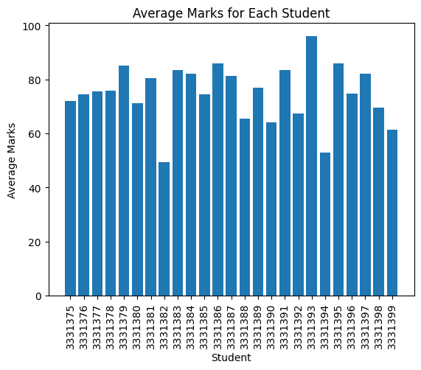

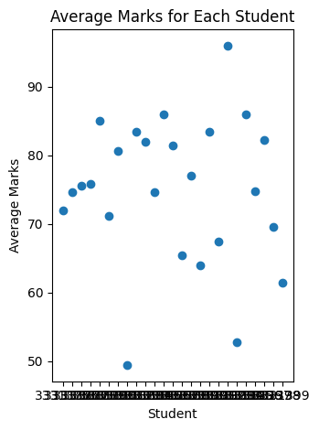

**Code:**

import matplotlib.pyplot as plt

data = {

    'Exam seat no': ['3331375', '3331376', '3331377', '3331378', '3331379', '3331380', '3331381', '3331382', '3331383', '3331384', '3331385', '3331386', '3331387', '3331388', '3331389', '3331390', '3331391', '3331392', '3331393', '3331394', '3331395', '3331396', '3331397', '3331398', '3331399'],

    'paper 1': [80, 75, 90, 59, 85, 65, 88, 54, 86, 85, 85, 98, 85, 58, 58, 75, 95, 68, 98, 45, 98, 78, 90, 65, 50],

    'paper 2': [70, 65, 65, 68, 82, 75, 78, 25, 86, 87, 69, 85, 68, 86, 86, 59, 65, 65, 95, 65, 85, 73, 85, 67, 55],

    'paper 3': [75, 87, 75, 75, 88, 73, 98, 65, 75, 64, 78, 84, 78, 47, 65, 45, 75, 67, 97, 54, 86, 74, 92, 62, 64],

    'paper 4': [50, 92, 63, 92, 83, 65, 87, 58, 95, 78, 71, 87, 89, 58, 78, 56, 84, 62, 96, 55, 81, 75, 68, 78, 60],

    'paper 5': [85, 54, 85, 85, 87, 78, 52, 45, 75, 96, 70, 76, 87, 78, 98, 85, 98, 75, 94, 45, 80, 74, 76, 76, 78]

}

# Calculate average marks in each subject

averages = []

for i in range(1, 6):

    subject_marks = data['paper ' + str(i)]

    average = sum(subject_marks) / len(subject_marks)

    averages.append(average)

# Visualize the average marks in a bar graph

subjects = ['paper 1', 'paper 2', 'paper 3', 'paper 4', 'paper 5']

plt.bar(subjects, averages)

plt.xlabel('Subjects')

plt.ylabel('Average Marks')

plt.title('Average Marks in Each Subject')

plt.show()

**Output:**

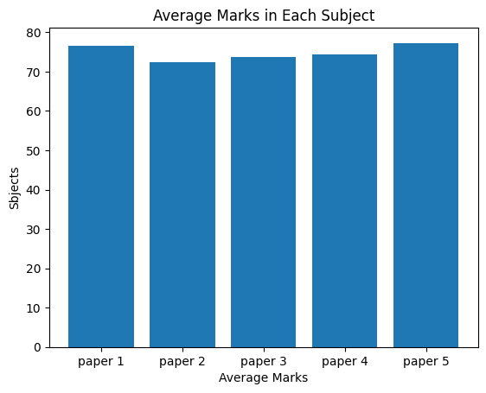

**Code:**

import matplotlib.pyplot as plt

data = {

    'Exam seat no': ['3331375', '3331376', '3331377', '3331378', '3331379', '3331380', '3331381', '3331382', '3331383', '3331384', '3331385', '3331386', '3331387', '3331388', '3331389', '3331390', '3331391', '3331392', '3331393', '3331394', '3331395', '3331396', '3331397', '3331398', '3331399'],

    'paper 1': [80, 75, 90, 59, 85, 65, 88, 54, 86, 85, 85, 98, 85, 58, 58, 75, 95, 68, 98, 45, 98, 78, 90, 65, 50],

    'paper 2': [70, 65, 65, 68, 82, 75, 78, 25, 86, 87, 69, 85, 68, 86, 86, 59, 65, 65, 95, 65, 85, 73, 85, 67, 55],

    'paper 3': [75, 87, 75, 75, 88, 73, 98, 65, 75, 64, 78, 84, 78, 47, 65, 45, 75, 67, 97, 54, 86, 74, 92, 62, 64],

    'paper 4': [50, 92, 63, 92, 83, 65, 87, 58, 95, 78, 71, 87, 89, 58, 78, 56, 84, 62, 96, 55, 81, 75, 68, 78, 60],

    'paper 5': [85, 54, 85, 85, 87, 78, 52, 45, 75, 96, 70, 76, 87, 78, 98, 85, 98, 75, 94, 45, 80, 74, 76, 76, 78]

}

# Calculate average marks in each subject

averages = []

for i in range(1, 6):

    subject_marks = data['paper ' + str(i)]

    average = sum(subject_marks) / len(subject_marks)

    averages.append(average)

# Visualize the average marks in a scatter diagram

plt.scatter(range(1, 6), averages, c='blue', alpha=0.7)

plt.xlabel('Subjects')

plt.ylabel('Average Marks')

plt.title('Average Marks in Each Subject')

plt.xticks(range(1, 6))

plt.yticks(range(50, 101, 10))

plt.show()

**Output:**

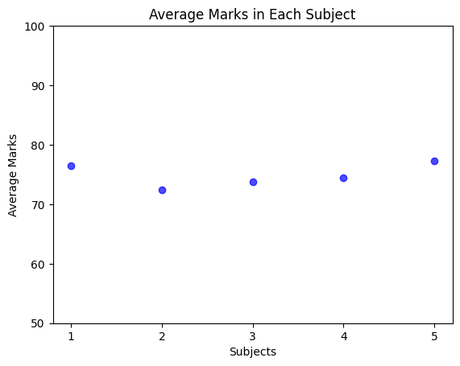

**Box Plot**

**Code:**

import numpy as np

import matplotlib.pyplot as plt

data1=([20,25,22,18,16])

data2=([32,45,40,46,30])

data3=([56,50,45,40,56])

data4=([60,56,63,58,66])

data=[data1,data2,data3,data4]

plt.boxplot(data1)

plt.boxplot(data)

**Output:**

